These days in the process of communicating with you, I found that many friends do not understand candlestick charts, which is a very bad thing, so I specially prepared some basic knowledge of candlestick charts tonight, and now sharing it with you, I hope that those who do not understand it can read it carefully!
I would like you to be quiet while I share with you, so you can save the lesson and consult privately with my assistant, Pratima Bansal, if you don't understand anything!
We know that candlestick charts have an opening price, a closing price, a minimum price, and a maximum price, four elements. To see the long and short forces should focus on these four elements, not just the color of the candlestick chart, but the price.
Comparison of the long and short formula: the highest price - closing price = more: closing price - the lowest price = short, a single candlestick can only represent the day of the contrast between the power of long and short, but if you want to "operation" or to combine "trend".
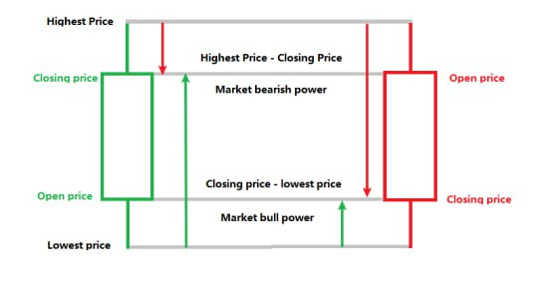
Let's take a look at the classic long-performance candlesticks
1. Green bullish candlestick to reflect the buyer's dominance, the longer the green line entity, indicating that the stronger the buyer's power, here I am from the strong to the weak, left and right in order for you to do the image labelled
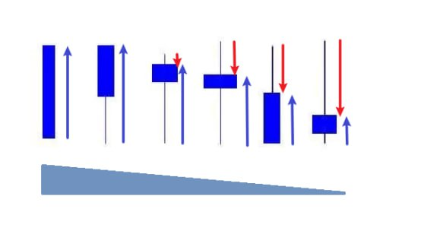
2. A red bearish candlestick indicates that the sellers are dominant the longer the red bearish candlestick entity the stronger the seller's power.
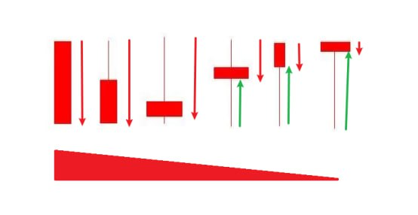
3. In the daily study, we must not use a single up or down to judge today's trend, but use the way to judge the strength of the short and long contrast, through the study and understanding of the calculation of the strength of the short and long, we can effectively separate today's closing candlestick or closing candlestick of the reliability of the closing candlestick, as an example:
In the stock ITC, December 4 closed down the red line, with the highest price of 456.4 closing price of 454.05 lowest price of 451, in today's candlestick chart long power: 454.05-451 = 3.5; short power 456.4-454.05 = 2.35, it is clear that although the number 4 closed down the red candlestick chart, today's bulls are slightly stronger than the Short
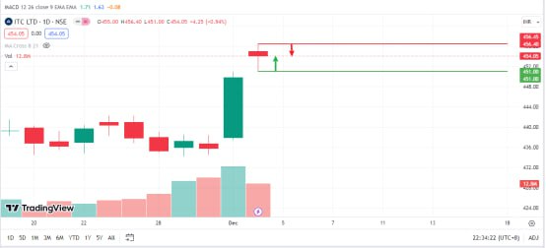
In the stock BAJFINANCE on 17 Oct 23, short strength = high price 8159 - close price 8093 = 66; long strength = close price 8093 - low price 8057 = 36. Although it closed with an upward green line, the short side was stronger than the long side strength.
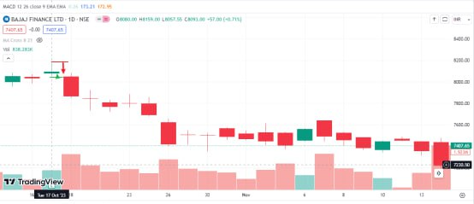
Next, we learn the significance of single candlestick charts or combinations in a staged market.

When the trend and the single candlestick indicate the same long and short forces, it means that the future single candlestick resonates with the trend, and the probability of running along the direction of the trend is greater.
1. Uptrend, as shown in the chart: uptrend is more dominant, indicating that the rise did not stop, we can see that when the price breakthrough A the long clearly began to perform strongly (Figure marked B) then the price rising the rising process of the long has been suppressed in the short!
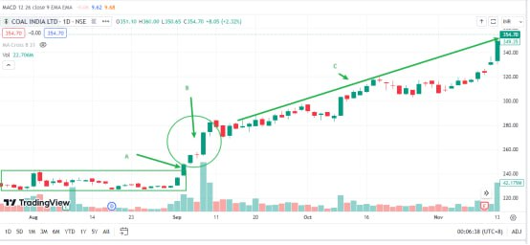
2. Downtrend, as shown in the figure: the downtrend of the empty war superior, the decline will continue. I use the simplest and intuitive up and down arrows to represent the power of the multiple and empty convenient for everyone to understand, learn today's method. I think that even if the price is low, you will not buy such a stock!
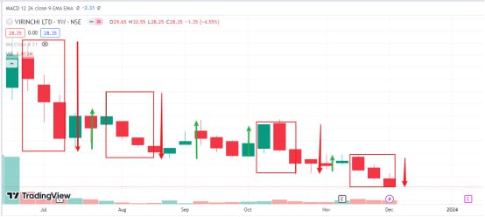
3. Buying opportunities and stop-loss judgment in the uptrend
The uptrend is the emergence of empty dominance there may be a rising relay or washout in the absence of a break below the neckline can be assured of holding and negative or you buy the opportunity.

For example, the BHARTIARTL chart price breakthrough in the previous box structure (Figure A) in the uptrend in the long began to prevail (Figure B) a total of 2 times empty dominant candlestick combinations (Figure C, E) but the upward trend did not change there are 2 times the trend line to get effective support, when the long re-dominance, and from the support level is closer to the support level, then D and F will be a good opportunity to buy. Their stop-loss prices are also relatively low, and they can be sold when they fall below the trend.
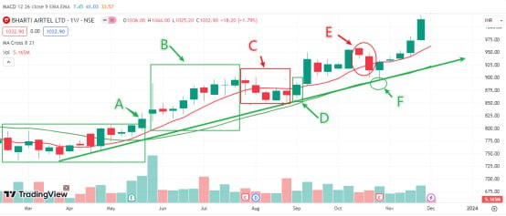
4. Downtrend how to find escape opportunities and reversal opportunities

As shown in the figure: the downtrend in the A short is clearly dominant, in the long accounted for in the rebounding market B, the short once again dominant is to escape the opportunity to C, the market breakthrough in the pre-decline channel, the dominant can be light to buy, when the structure of the ascending channel E formation is obvious, the price of back to step on the trend line is not broken and the dominant to re-possess can be regarded as a signal to increase positions!
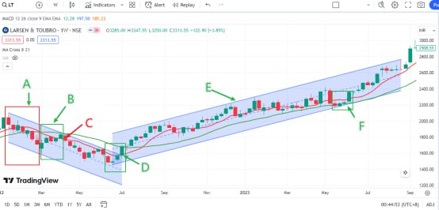
Learn more about the support and resistance of single candlestick charts in special situations.

Candlestick charts without upper and lower leads or with very long upper and lower leads. This kind of candlestick will show strong support or resistance if it appears in a special trend, such as the top or bottom of the market a key position, or a signal for a trend reversal (as shown in the chart) where I don't have the standard candlestick colors, and where resistance and support depend on whether the current price is under the candlestick or above it.
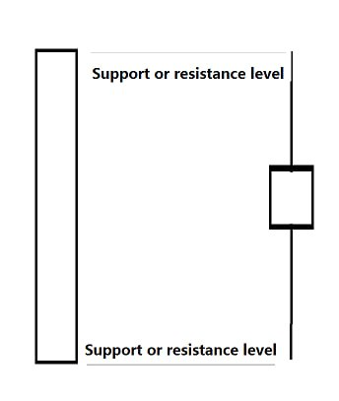
|Single candlestick charts of the long and short language will give you said here the basics that seem simple but are frequently used in daily trading, not only the trend of broken judgment, and averages. MACD indicator analysis of wave institutions to confirm the shape of the judgment of the form of strong functionality. We must practice more when we see these candlestick charts; the first reaction is to determine the strength of the short and long, whether the support and resistance are valid!
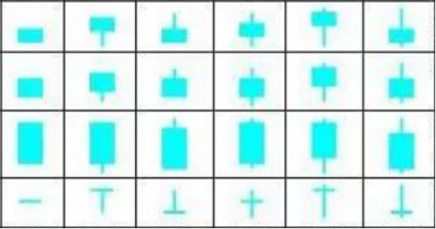
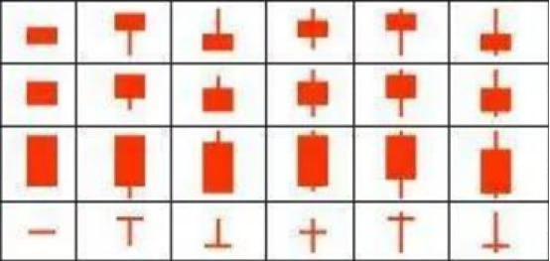
The last two charts cover all the single candlestick patterns. If you are eager to learn and want to master the art of stock market trading, I have a homework assignment for you. Please evaluate the strengths and weaknesses of both long and short positions represented in each chart. Once you have completed this task, send your findings to my assistant, Pratima, who will verify that you have marked them correctly. If you can complete this assignment independently, I truly believe you will become a skilled trader in the stock market in the future.
So that's all I have to share tonight see you tomorrow

